Prescribing Tip No. 198 Date: 6th April 2018
Launch of Netformulary
The joint prescribing formulary developed between Greater Preston and Chorley & South Ribble CCG’s and Lancashire Teaching hospitals has now been reformatted and relaunched. It can be accessed via Netformulary using the following link www.centrallancashireformulary.nhs.uk. The IT department are in the process of installing a shortcut to Netformulary on all practice PC’s – the shortcut will appear on the desktop as the 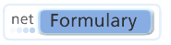icon. Netformulary can also be accessed via an App and details for downloading the App can be found here.

The formulary is structured using a similar lay out to the BNF and allows users to search for the local formulary choices of drugs across a wide range of indications.

Searching Netformulary

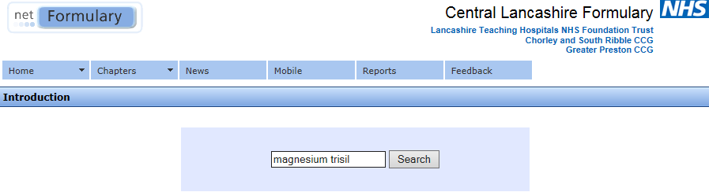

Netformulary can be searched by clicking on the Chapters button (which can be found on the home page of the website) or by entering the drug name or the indication to be treated in the search box.

Order of preference of drugs

All drugs included within Netformulary are RAG rated (RED, AMBER and GREEN) using the same system as the Lancashire Medicines Management group website. Many sections of the formulary are arranged to indicate first/second/third line choices for their prescribed indications.

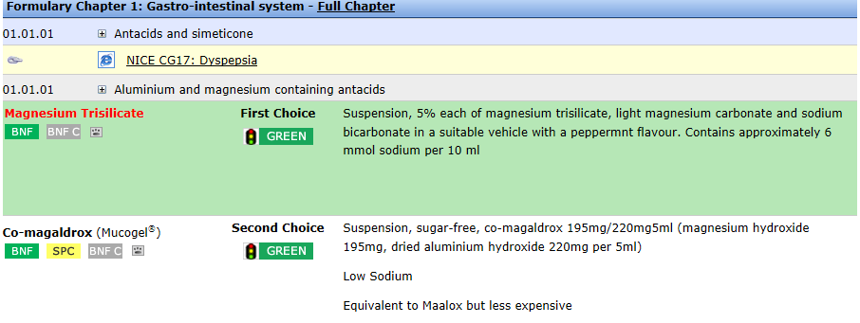
The home page of the website provides useful links to

- LMMG (Lancashire medicines management group) website
- Medicines and Healthcare products Regulatory Agency (MHRA) – for adverse drug reaction reporting and access to product SPC’s (summary of product characteristics) and PIL’s (patient information leaflets)
- NICE guidance
- The online BNF
- SharePoint – for access to local guidelines/formularies and PGD’s

To contact the Medicines Optimisation Team please phone 01772 214302

